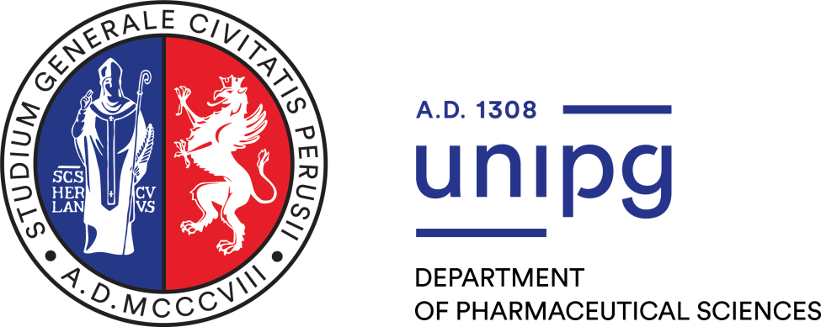

DOCTORATE IN PHARMACEUTICAL SCIENCES
(XXXVIII or XXXVII cycle)

Curriculum: Early Phase Drug Discovery or Pharmaceutical Technology and Nutraceuticals

1st or 2nd Year PhD Report

TITLE

PhD STUDENT: | SUPERVISOR(S):
Name and Lastname | Name and Lastname

- ABSTRACT

Text …

- INTRODUCTION

Text …

- AIM OF THE WORK

Text …

- RESULTS AND DISCUSSION

Text …

- EXPERIMENTAL SECTION

Text …

- CONCLUSION AND PERSPECTIVES

Text …

- REFERENCES
Use this format:
- Journals
(all the authors) Brown, E. D.; Wright, G. D. Antibacterial drug discovery in the resistance era. Nature 2016, 529, 336– 343
- BOOKS
-Reichardt, C. Solvents and effects of solvents in organic chemistry; VCH: Weinheim, 1990; vol. 4, pp. 298-311
-Furniss, BS; Hannaford, AJ; Smith, PWG; Tatchell, AR Vogel's Textbook of Practical Organic Chemistry, 5th Edition; Wiley: New York, 1989; pp 64-67.

